CSCI 2467
Lab 6

1. Write a program that contains the following two methods:
public static double celsiusToFahrenheit(double cels)
public static double fahrenheitToCelsius(double fahr)
Both of these methods will return a converted temperature. The main method will prompt a user for the number of conversions they would like to make. Use that number for the counter control of a for loop. Make sure that the numeric output has one decimal place.

Turn in: TempConverter.java

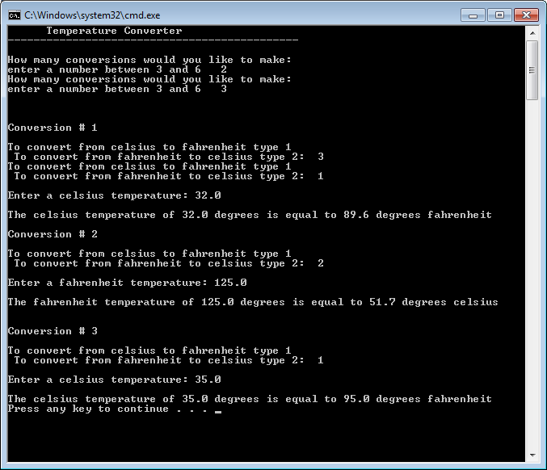

over
2. Download the Traffic.java shell and complete the methods. The getLimit(), getDriverSpeed() and getTickets() methods should retrieve input from a dialog box and error check for input < 0. The fine is calculated at $20.00 * number of miles over the speed limit. The court costs are calculated as follows:
0-1 previous ticket - $74.80
2 previous tickets - $99.80
3 or more - $124.80
If cancel is clicked on any of the input dialog boxes, the program should call finish().
Hint: if (answer==null) finish();
If the driver’s speed is less than the posted speed, there was no violation and the program ends.
Turn in: Traffic.java
